Team Pluvali

Alex Davis

Steve Kosovich

Tim Leikam

Greg Martini

Debra Parcheta

Katie Taliercio

Coping Skills Game: Detailed Testing Instructions

Steps:

1) Turn on and log in to a computer, tablet, or phone.

2)While connected to the Internet, open a browser (Internet Explorer, Firefox, Chrome, Safari, etc.) and go to: <http://coping.ddrcweb.com/admin> . You can also just go to the game's main site, log in as an administrator, and there will be a link to the admin page in the top left corner of the Home page.

*You can copy the link above and paste it in the URL, as shown below.*

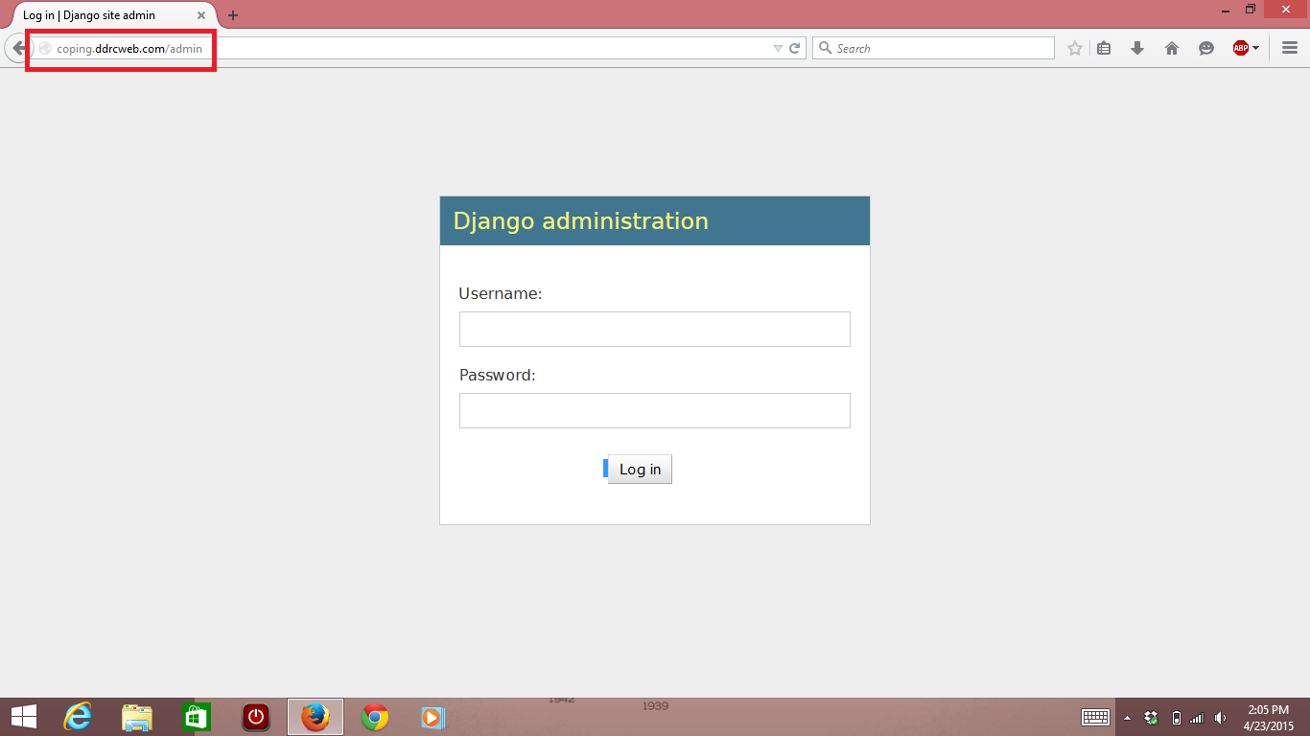

3) Now log in with an administrator account, and you will be brought to the interface.

*The username: admin and the password: admin will log you in as an admin for now. A picture of the interface after you log in is shown below:*

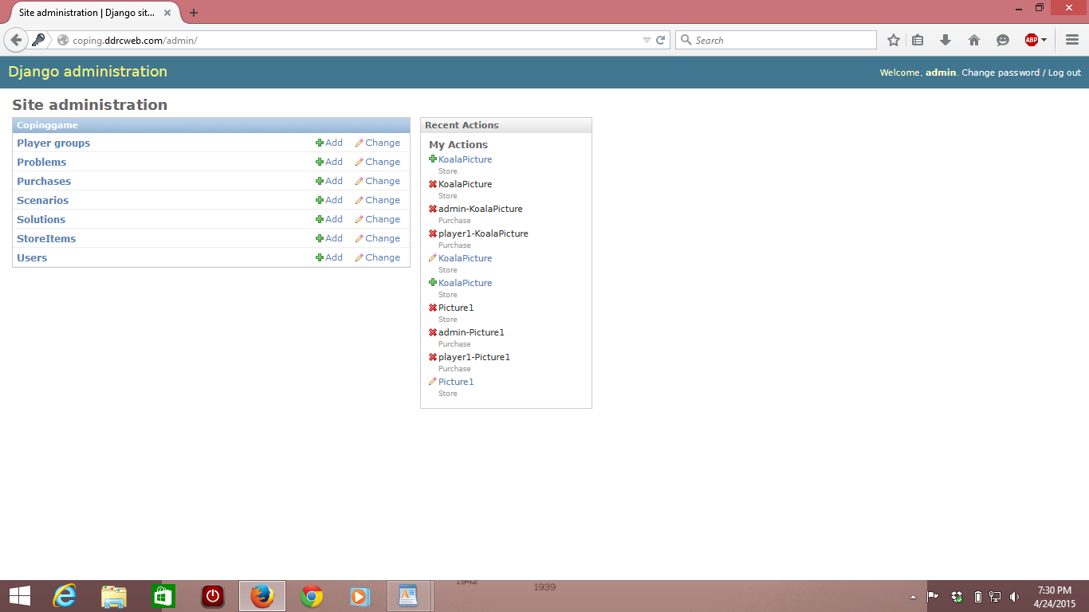

4) To create a new scenario from scratch, you'll need to create your own set of problems and solutions, but you may also use problems and scenarios already in the database. In order to create your own problem, you'll first need to create your own solutions if you wish to use your own.

If you don't wish to create your own solutions, then please go to step 5. Clicking on “Solutions” will take you to the following page. Each problem will need 1 solution and allows a maximum of 3 solutions.

*The Solutions page is shown below:*

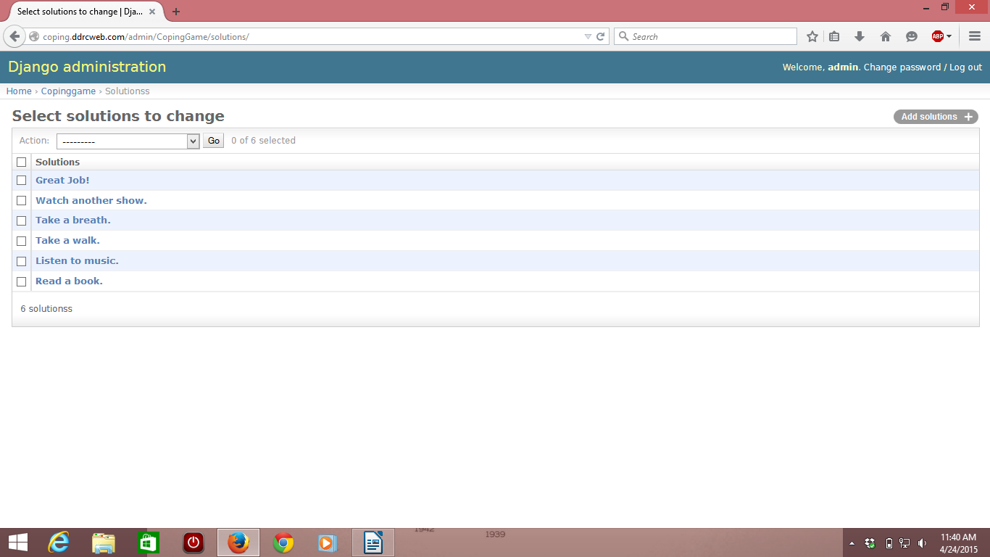

To add a new solution, click on the “Add solutions +” button located near the top right corner of the screen.

You will need to add a picture from your computer/tablet/phone for the solution. You may use a picture you already have or save one from the Internet and then upload it. In addition, you'll also need to name your solution. This name will be shown to players as the name of the solution, for example “Go on a walk.” Lastly, you'll need to add a SvideoId to the solution. This can be found by going to YouTube, finding a video that fits your solution, and copying the portion of the URL of the YouTube video (shown below) and paste it into the SvideoID text area (copy everything after the = sign). This video will be used to show the player a visual example of the solution you're creating.

*The Add solutions page is shown below, along with a picture of what to get from the URL in a YouTube video:*

*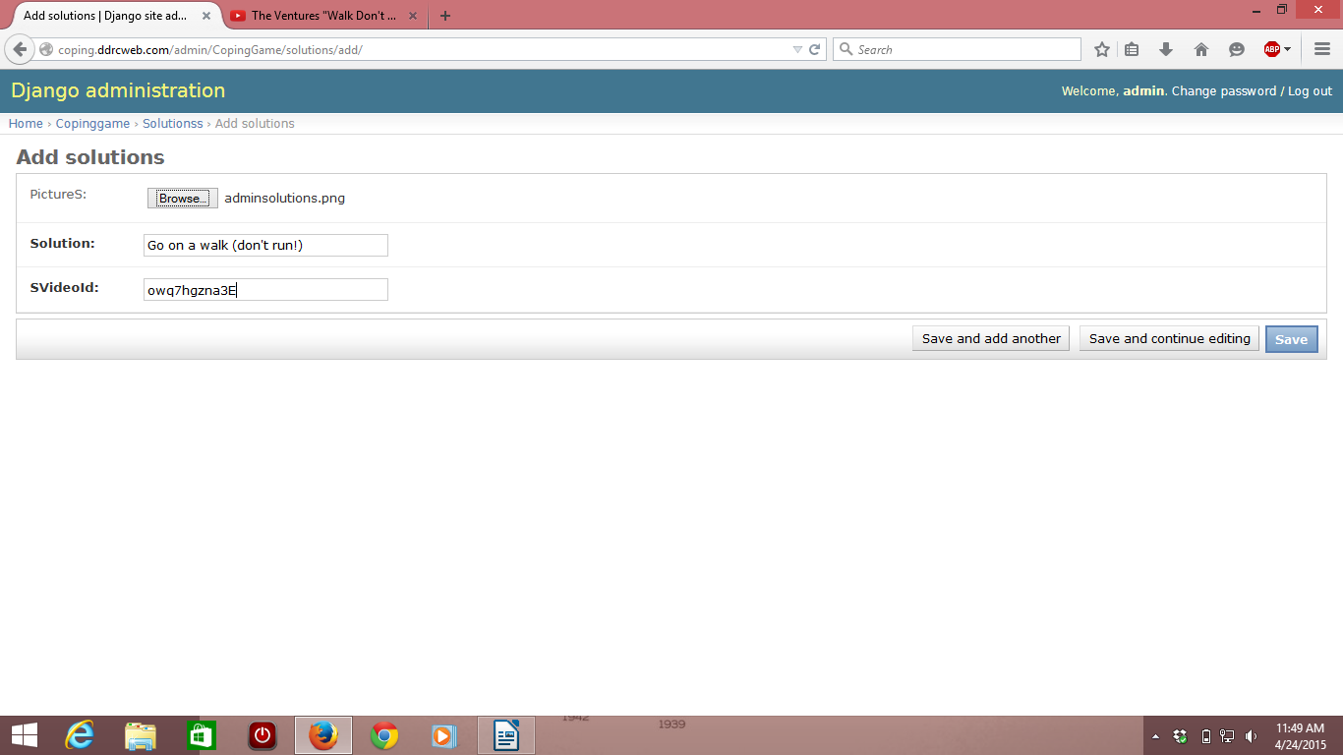*

*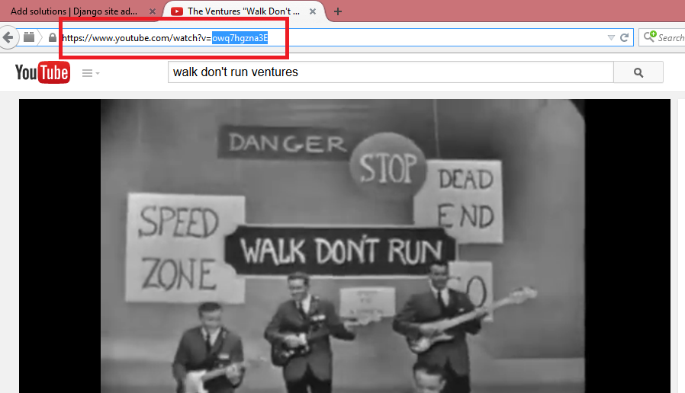*

After you have the picture uploaded, the solution named, and a video selected, click on the “Save” button in the Add solutions page to save your solution.

5) If you do not wish to create your own problems, then please go to step 6. Click on “Problems” from the main admin page (you can get back to the main admin page by clicking on “Copinggame” in the path at the top left of the page, or by going to the URL coping.ddrcweb.com/admin). Each scenario needs a minimum of 1 problem, and allows a maximum of 5 problems (3 is recommended for optimal formatting).

*The Problems page is shown below:*

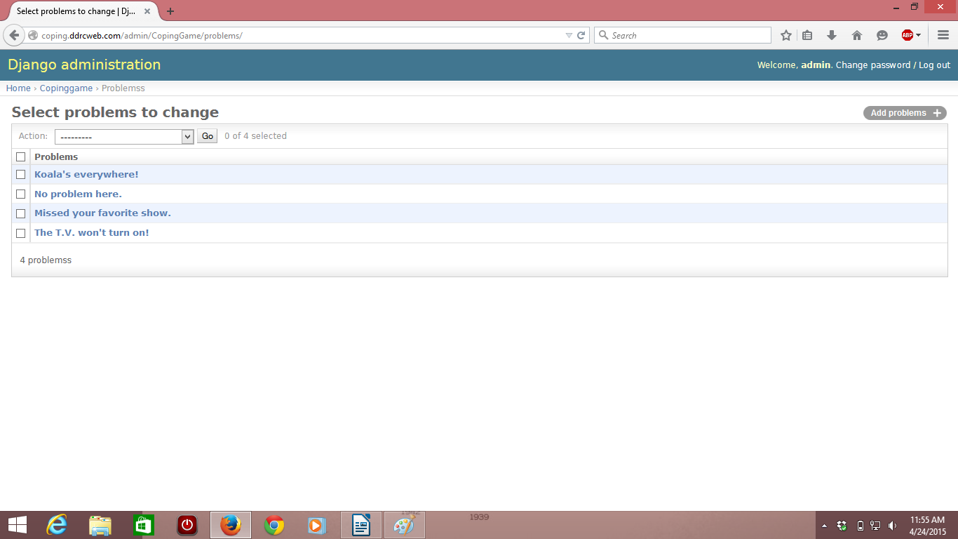

To create a new problem, click on “Add problems +” in the top right corner of the page.

As with solutions, the PictureP must be uploaded from your computer. This picture will display as the overall picture to represent the problem you're making.

The Problem field will need to be filled with whatever you wish to describe your problem as. For example, “My neighbor is being loud.”

PvideoID works the same way as it did in solutions, you'll need to find a video to represent your problem on YouTube and copy the following portion of the URL into the text area (A YouTube video will always go something like: https://www.youtube.com/watch?v=. You do not need to worry about that. You need to get what is after the = in the URL to put in PvideoID). This video will play automatically and will give a video example of what your problem is.

*The Add problems page is shown below, with the PvideoID highlighted in blue:*

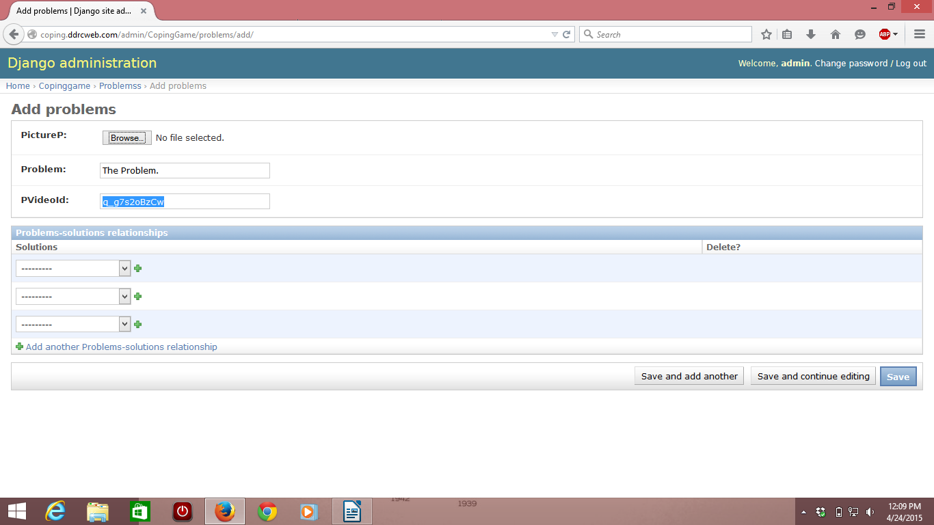

After this, select which solutions you want the players to choose between as a solution to your problem. Click on the drop down arrow and select the solutions you wish to use.

If a solution you need doesn't exist that you want to use, click the green plus button in the Solutions to make one.

Once you have a picture, description, video, and solutions selected, click on the “Save” button in order to save your problem.

6) Navigate back to the main admin page, if you're not already there, by clicking on the blue “Copinggame” link in the path located near the top left of the page. Then click on the “Scenarios” from the main admin page to get to the Scenarios page.

*The Scenarios page is shown below:*

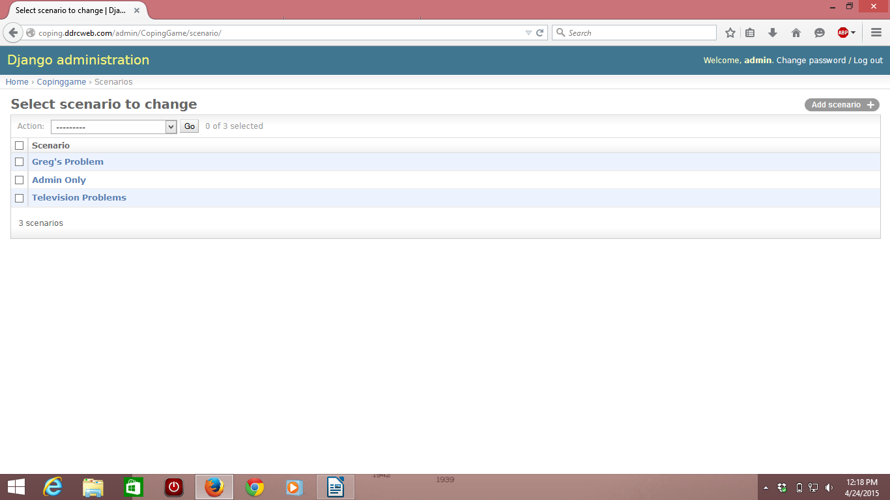

To add your own scenario, click on the “Add scenario +” located in the top right corner of the page.

Fill in the “Title” field with what you want your scenario to be named, like “Roommate Problems.” You can add a description of the scenario if you wish to have one, but it's not required.

Select which problems you want your scenario to have by using the drop down arrows in the “problems” section of the page shown below.

To be able to choose which players can see and play your scenario, you can do this in one of two ways:

1) Select every player individually using drop down arrows in the “players” section. You will have to add more people with the green plus sign if you have more than three.

2) Select the player groups you wish to have access to your scenario using the drop down arrows in the “player groups” section. If you have more than three player groups, you will need to add more with the green plus sign.

After naming your scenario, choosing which problems are in it, and selecting which players can play your scenario, click on the “Save” button.

*The Add scenarios page is shown below:*

*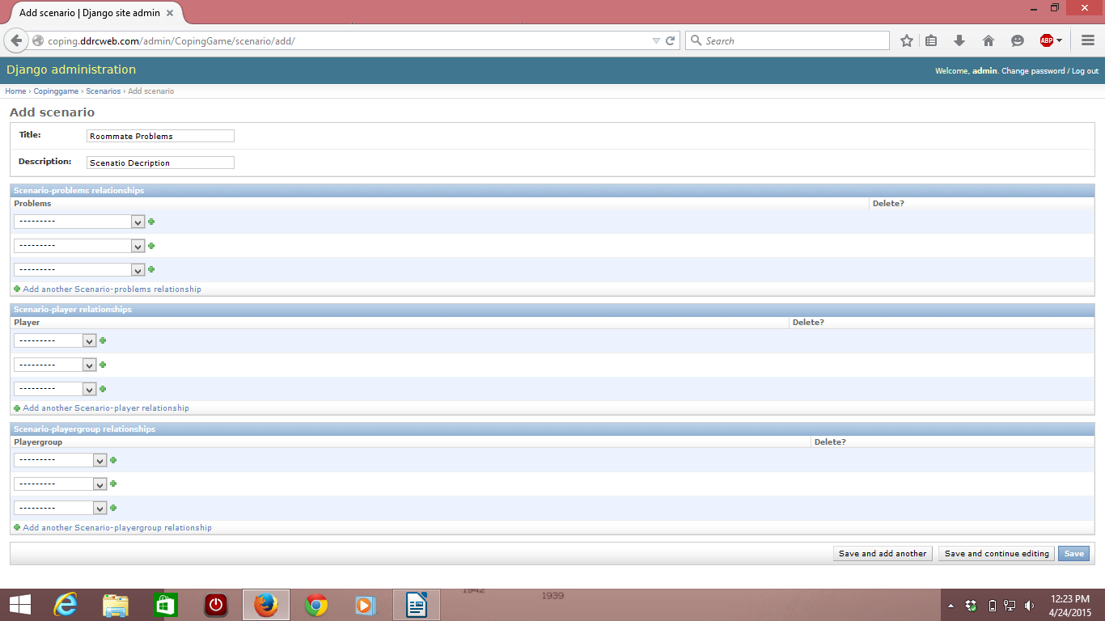*

If nobody is selected in either of the two fields (Player or Playergroup), it will still work, but nobody will be able to play the scenarion.

If a player is in one field but not the other (say you add someone in Player but not in Playergroup), that player will be able to see and play the scenario in the game.

If a player is added to both Player and Playergroup, they should be able to see and play the scenario in the game.

7) Navigate back to the main admin page, if you're not already there, by clicking on the blue “Copinggame” link in the path located near the top left of the page. Then click on the “Player groups” link from the main admin page to get to the Player groups page.

*The Player Groups page is shown below:*

*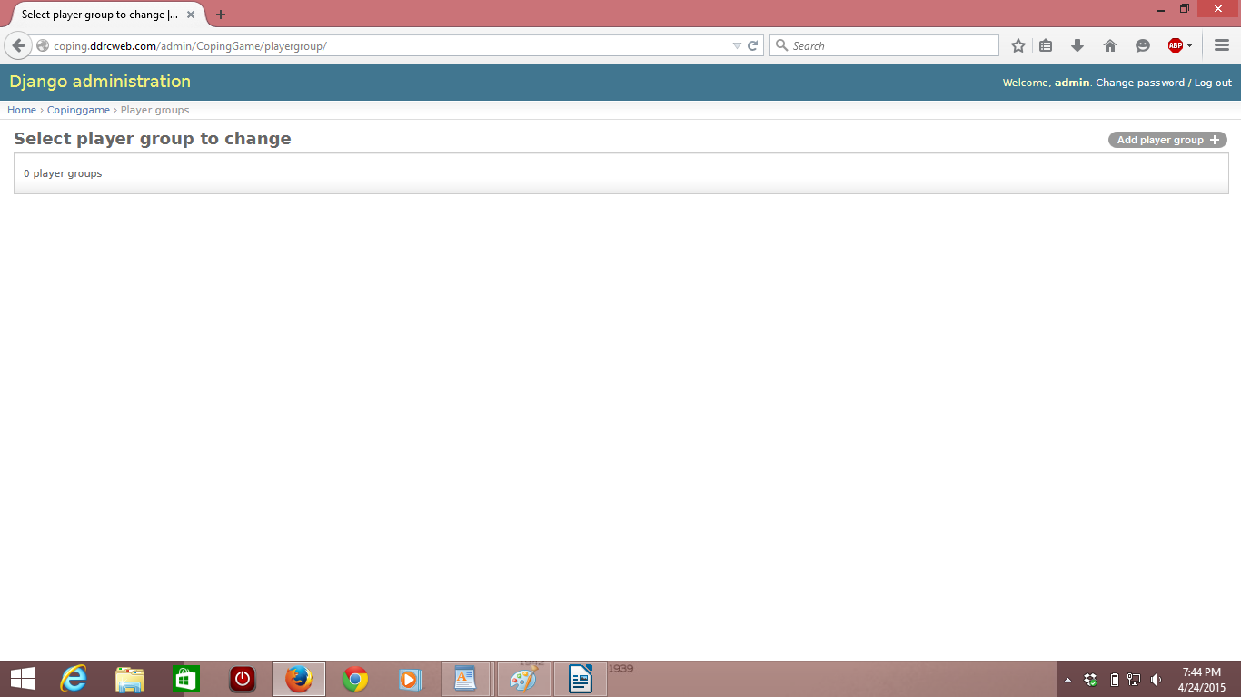*

Click on the Add player group button to make a new player group. It's very easy. First, you give the player group a name, then select the players you want in the group by either Ctrl+left click to select one player at a time, or Shift+left click to select all the players from click to click, inclusively.

*A screenshot showing “admin” and “steve” being added to a new group called “Admin's Group” is shown below:*

*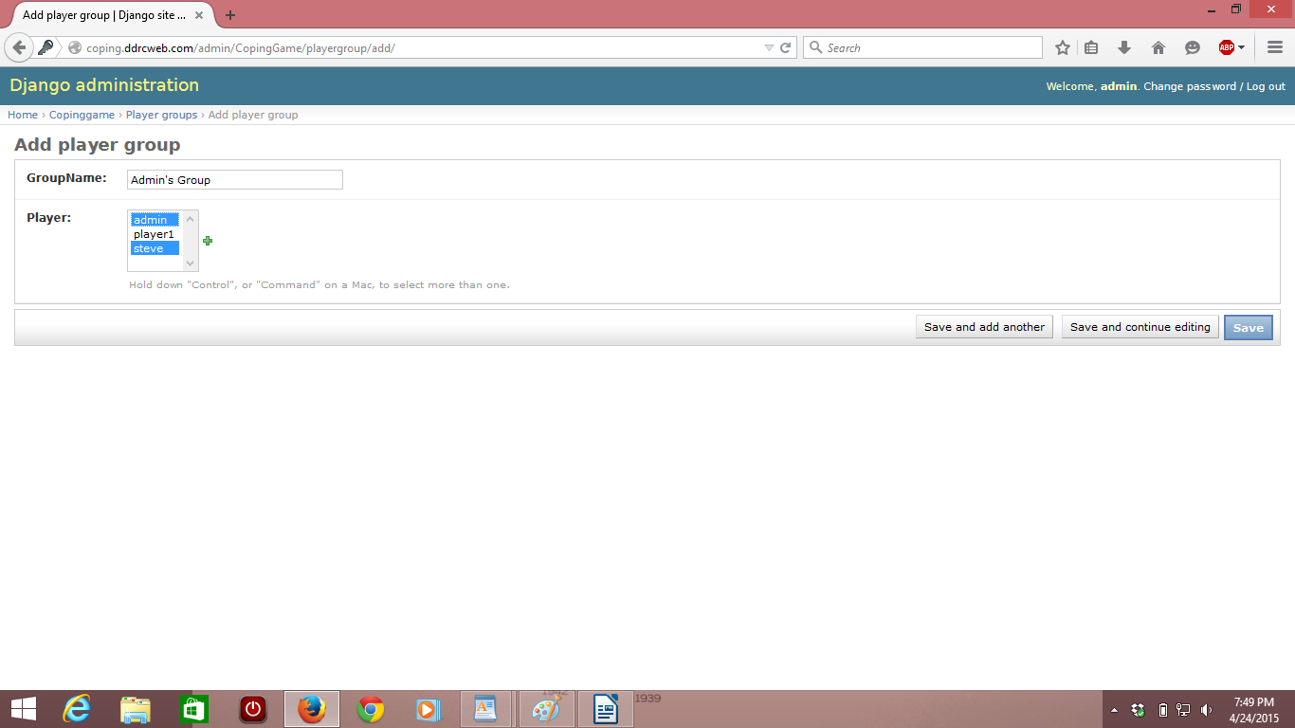*

ADDING STORE ITEMS:

Go to the “Stores” link from the main admin page (click on the Coppinggame link near the top left of the page if you are not already there).

*The Store page is shown below:*

*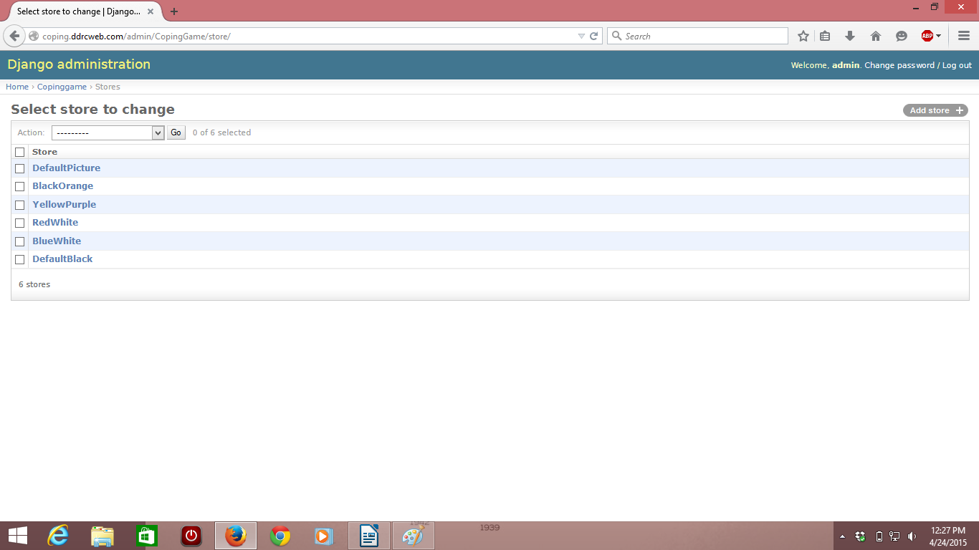*

Once there, click on the “Add store +” button in the top right of the page. The store only has two categories, Themes and Pictures.

*The Add store page is shown below:*

*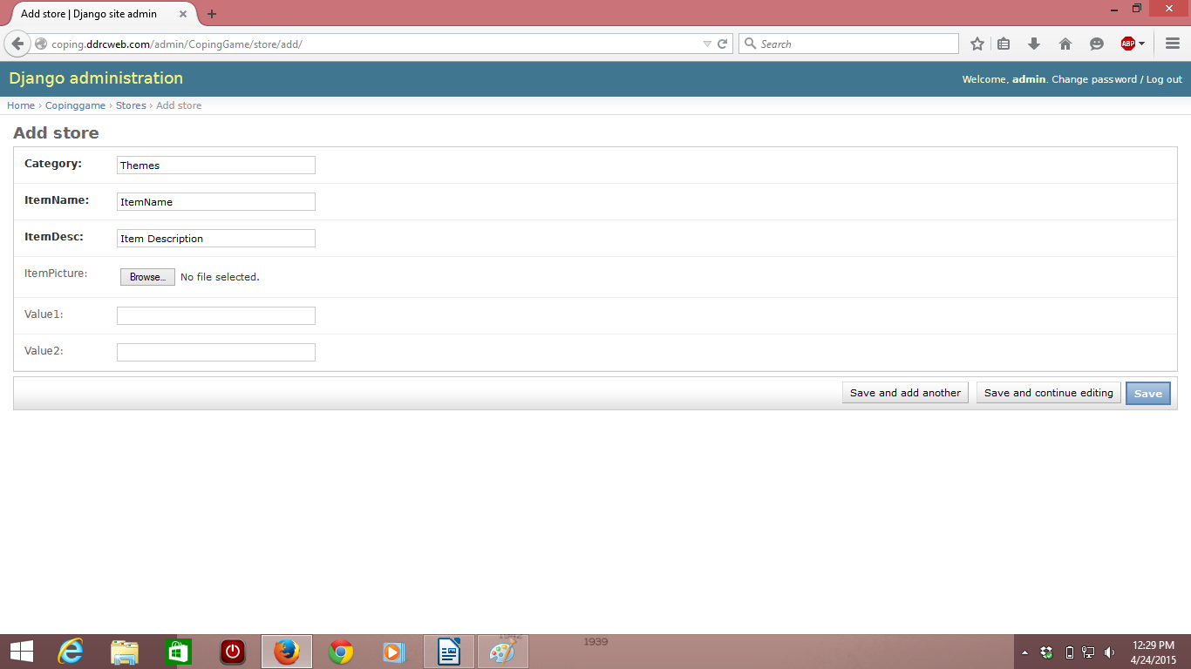*

THEMES:

To add a Theme, leave the Category field as “Themes”. Name your theme by filling in the ItemName field with whatever you wish, but it's best to name it something logical (for example, the color combination of the theme, like “GreenWhite”). Also give your theme a description to describe it, like “Green background with white text.”

You'll use the “Bg” and “Text” fields. Bg correlates to the background color of the web page, and Text is what the text color will be. You can use most color names (like “red”, “green”, “orange”, etc), or you may use the Hex value of a color, which the following website can help you look up.

<http://www.w3schools.com/cssref/css_colorsfull.asp>

Ignore the itemPicture field when creating themes. Once you have the appropriate category, name, description, and color values, click the “Save” button to save your theme.

PICTURES:

To add a picture, change the category field from “Themes” to “Picture” by typing it in.

In order to add a picture, you'll upload a picture from your computer. In order to add a picture from online, you'll have to save a picture from online. Click on the browse button next to “ItemPicture” and choose whatever picture you wish to add to the store.

Ignore the Bg and Text fields when adding a picture. Once you have the appropriate category, name, description, and picture selected, click the “Save” button to save your picture.

Note that for testing purposes, it is advisable not to delete scenarios and purchases (unless you created them), as it is difficult or impossible to get them back. To delete something, from a page (say the Players page), check the box next to the item you want to delete, then click on the dropdown called “Action” and choose “Delete selected players” and press “GO”. You will ask if you really want to do it, and say “Yes I'm sure” if you mean it, or back out if you don't.

If something does get deleted or removed, please send us an email and we will try to fix it as soon as possible. It is especially advisable not to delete the default Scenarios, Solutions, Player groups, Store, Players, Problems and Purchases (like the television problems, player1 and admin players, the BlueWhite themes, etc.).